Chapter 2, Solution 81

In a certain application, the circuit in Figure 2.140 must be designed to meet these two criteria:
(a) V_{o} / V_{s} = 0.05 (b) R_{eq} = 40 kΩ

If the load resistor 5 kΩ is fixed, find R₁ and R₂ to meet the criteria.
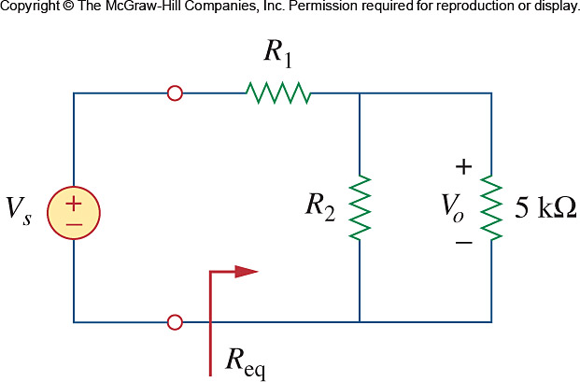

Figure 2.140
For Prob. 2.81.

Let R₁ and R₂ be in kΩ.

(1)
(2)

From (1) and (2), 2 = or R₂ = 3.333 kΩ
From (1), 40 = R₁ + 2 R₁ = 38 kΩ

Thus,

R₁ = 38 kΩ, R₂ = 3.333 kΩ

